BEAR SAFETY TIPS
Prepared by the Be Bear Aware Campaign
406-239-2315 bearinfo@cfwi.org
BeBearAware.org

As bear populations have grown across North America, the suggestions for safety techniques have changed over time. The information listed below has been developed with help from federal and state wildlife agencies, outfitters and guides, Backcountry Horsemen, and hunting organizations.

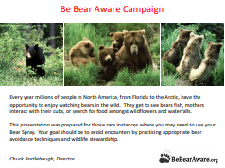
- BEAR AWARENESS POWERPOINT
This slide show covers a wide variety of bear safety topics including picking out and setting up your camp, food storage, hiking precautions, bear encounter scenarios, safety techniques for going off trail or retrieving game, tips for purchasing a quality bear spray and how to properly use bear spray. It also includes videos depicting bear behavior. https://www.youtube.com/watch?v=JBqi9HoS7RM
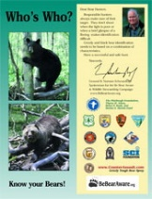
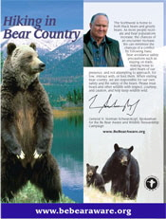
- HIKING IN BLACK BEAR & GRIZZLY BEAR COUNTRY BOCHURE
This brochure emphasizes the appropriate safety techniques to use when hiking in either black bear or grizzly bear country. It includes safety precautions for children, encounters with cougars and snakes, and a special section that explains the most common causes of conflicts with bears.
Because most states within the lower 48 states only have black bears, we also have a black bear specific brochure similar to this one that features information about black bears. It can be found at https://bebearaware.org/products-materials/.
- WHO’S WHO BROCHURE Has an introductory message from the late General Schwarzkopf emphasizing the importance for recreationists to know the difference between black bears and grizzly bears. It contains bear identification tips and a fun picture quiz.
https://bebearaware.org/files/2020/03/WhosWho_KnowYourBears_Updated10.31.2016.pdf
BEAR SAFETY TIPS
CONTINUED

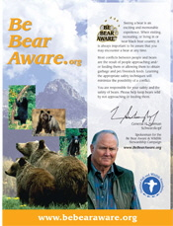
- BE BEAR AWARE BROCHURE This brochure emphasizes both black bears and grizzly bears and has special sections about not feeding bears, hiking safety tips, bear spray, camping tips, food storage, encounters, and residential safety precautions.
https://bebearaware.org/files/2020/03/BeBearAware_GrizzlyBear.pdf
This brochure is also available as a black bear only version with similar information and a special section about black bears at a glance. https://bebearaware.org/products-materials/
- BEAR SPRAY TRAINING VIDEO shows how to respond to a highly agitated charging bear. This includes within 60 feet, 30 feet, and two scenarios depicting bears charging from their day bed within 15 feet. Learn how to hold the bear spray cannister, remove the safety clip, and direct the bear spray. https://www.youtube.com/watch?v=TZ5HJHZ8Mfw&t=8s
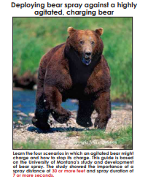
- BEAR SPRAY TRAINING GUIDE This 8-page magazine format compliments the above video and provides additional information such as guidelines for purchasing a quality bear spray; proper way to hold and deploy bear spray; how bear spray effects a bear; tips for avoiding close encounters; and first aid if you are sprayed. https://bebearaware.org/files/2020/02/BearGuide8Aug42019.pdf

YOU CAN MAKE A DIFFERENCE BY SHARING THIS INFORMATION
WITH FAMILY AND FRIENDS
BeBearAware.org youtube.com/bebearaware
facebook.com/bebearaware instagram.com/be_bearaware

