BE A BEAR SPRAY TRAINER
Prepared by the Be Bear Aware Campaign
406-239-2315 bearinfo@cfwi.org
BeBearAware.org

Become a bear spray trainer and do presentations for youth groups, schools, hunting & fishing organizations, and community events. Simply download the educational materials from the following links:

- BEAR SPRAY TRAINING VIDEO shows how to respond to a highly agitated charging bear. This includes within 60 feet, 30 feet, and two scenarios depicting bears charging from their day bed within 15 feet. Learn how to hold the bear spray cannister, remove the safety clip, and direct the bear spray. https://www.youtube.com/watch?v=TZ5HJHZ8Mfw&t=8s
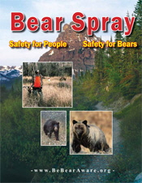
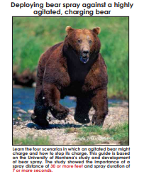
- BEAR SPRAY TRAINING GUIDE Compliments the above video in print form and provides additional information such as guidelines for purchasing a quality bear spray; proper way to hold and deploy bear spray; how bear spray effects a bear; tips for avoiding close encounters; and first aid if you are sprayed. We also justify why a bear spray should have 7+ seconds of spray duration and travel 30+ feet in distance in order to meet a variety of circumstances. https://bebearaware.org/files/2020/02/BearGuide8Aug42019.pdf
- BEAR SPRAY INSTRUCTOR’S GUIDE This 8-page magazine format provides more history about bear spray and a special section on misinformation. It is the predecessor to the video and training guide. https://bebearaware.org/files/2020/03/BearSpray_InstructorsGuide.pdf
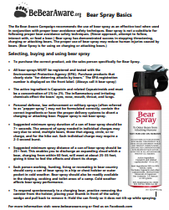
- BEAR SPRAY FACT SHEET Features key information about bear spray, including suggested minimum duration and distance, the active ingredients Capsaicin and related Capsaicinoids, and more.
https://bebearaware.org/files/2020/04/bearspraybasics.pdf

BE A BEAR SPRAY TRAINER
CONTINUED

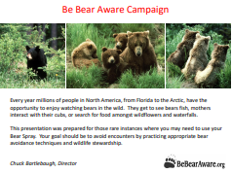
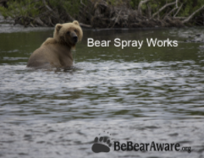
- BEAR SPRAY WORKS POWERPOINT PRESENTATION covers all aspects of bear spray from its research and development, the resulting industry standards, EPA registration, purchasing tips, what to look for on the can, why bear spray is different than pepper spray, and how to deploy bear spray properly.
https://www.youtube.com/watch?v=avNztm45DsE
- BEAR AWARENESS POWERPOINT PRESENTATION covers bear safety tips for hiking, biking, camping, hunting and fishing, and residential homes. Also includes the four most common bear charge scenarios and how to deploy bear spray in each situation. Perfect for classroom presentations.
https://bebearaware.org/files/2020/09/Bear_Awareness_PowerPoint_6-2-20-converted.pdf
- BEAR SPRAY TRAINING COURSE All the information you need to create your own bear spray course. This includes sign placement, sign sizes, a downloadable .pdf file that is print ready for printing the signs, information for accessories to the course, and proper layout. The Be Bear Aware Campaign does not charge for using its educational bear avoidance concept. However, you may incur charges from outside suppliers, and sometimes a sponsor or grant can help.
- ADDITIONAL BEAR SPRAY INFORMATION is available on the BeBearAware.org website https://bebearaware.org/ or on our YouTube page at: https://www.youtube.com/bebearaware Here you can find television news reports about bear spray, additional videos and print material to download and handout.
YOU CAN MAKE A DIFFERENCE BY SHARING THIS INFORMATION
WITH FAMILY AND FRIENDS
BeBearAware.org youtube.com/bebearaware
facebook.com/bebearaware instagram.com/be_bearaware

